Kubernetes Explained:
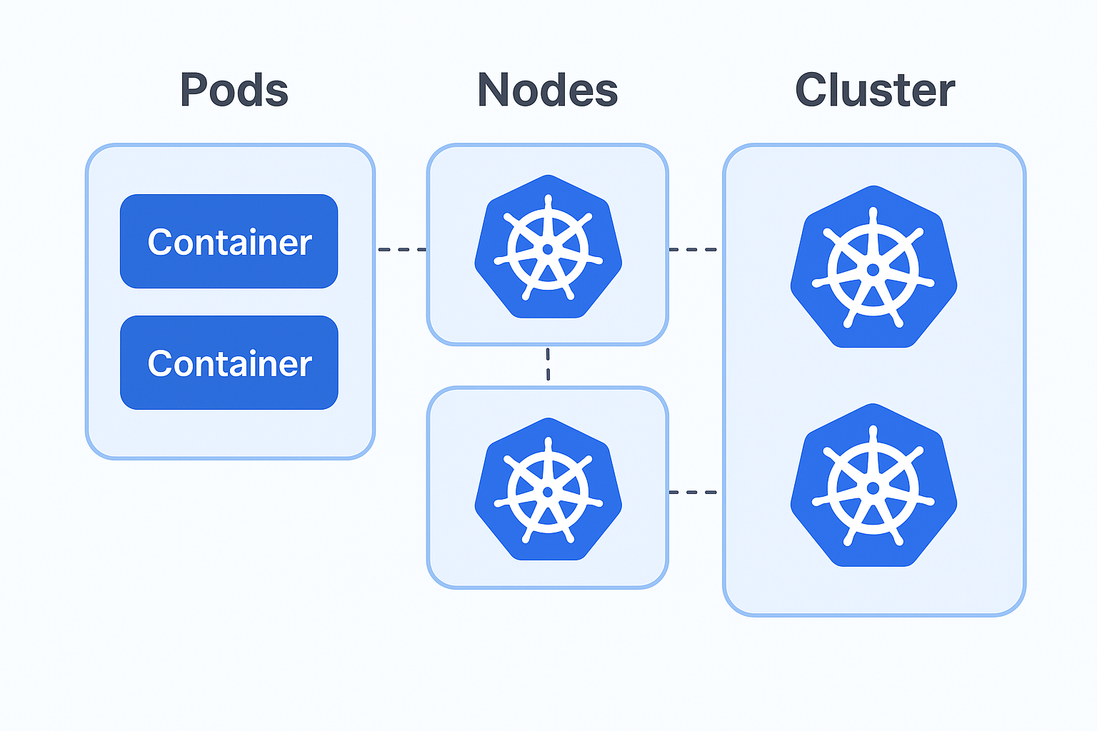

Excellent questions — you’re thinking about Kubernetes (K8s) at the right level of abstraction. Let’s unpack this clearly 👇

🖥️ 1. Are Nodes servers?
✅ Yes — Nodes are servers (machines), physical or virtual.
- Each Node runs part of your application’s workload.
- It has:
  - A container runtime (like Docker or containerd)
  - A Kubelet (the K8s agent that communicates with the control plane)
  - A networking component (for service communication)
Think of a Node as a worker in a larger distributed system.

📦 2. Are Pods virtual machines or equivalents?
❌ Not exactly.
A Pod is lighter than a virtual machine — it’s the smallest deployable unit in Kubernetes.
- A Pod groups one or more containers that share:
  - The same network IP address
  - The same storage volumes
  - The same lifecycle (they start, stop, and restart together)
So:
🧠 VM = isolated OS-level machine
📦 Pod = group of containers sharing resources within a Node
Kubernetes schedules Pods onto Nodes — many Pods can run on the same Node.

🌐 3. What are Clusters and their purpose?
A Cluster is the whole Kubernetes environment — it includes:
- One (or more) Control Plane nodes (the “brain” of K8s)
- Multiple Worker Nodes (where Pods actually run)
Purpose of a Cluster:
- Coordinate the deployment, scaling, and monitoring of applications.
- Make sure the desired system state (declared in YAML configs) matches the actual running state.
In short:
A Cluster = Control Plane + Worker Nodes + Networking + Storage.

⚙️ 4. Do servers run multiple independent instances of K8s, or is there one orchestrating multiple systems?
Usually:
- There is one Control Plane (K8s master) orchestrating many Nodes (which can be servers or VMs).
- You don’t run multiple independent K8s instances per Node — instead, you run one centralized K8s system managing all Nodes.
That said:
- You can have multiple clusters (for example, one for dev, one for prod), but each cluster has its own control plane.
- Within a single cluster, one control plane orchestrates all workloads.

🧩 Summary
Concept | Analogy | What It Runs
Container | App component | Your app or service
Pod | Container group | One or more containers
Node | Worker server | Runs Pods
Cluster | Entire system | Nodes + Control Plane
Control Plane | Brain / Manager | Decides where Pods run and ensures health

